SEC : A PROCESS AND SIGNALS BATCH : A3

REG: 190905513 LAB 03 NAME: MOHAMMAD DANISH EQBAL

LAB EXERCISES:

1. Write a C program to block a parent process until the child completes using a wait system call.

Program:

#include <stdio.h>
#include <stdlib.h>
#include <sys/types.h>
#include <sys/wait.h>
#include <unistd.h>

int main() {
printf("Parent process starting..\n");
int r_val = fork();
switch(r_val) {

case -1: {
perror("Fork\n");
exit(EXIT_FAILURE);
}
break;

case 0: {
printf("Inside the child process..\n");
for(int i = 0; i < 10; i++) {
sleep(1);
printf("Sleeping child process for %d seconds..\n", i + 1);
}
exit(0);
}
break;

default: {
printf("Waiting for the child..\n");
wait(NULL);
printf("Child process finished execution..\n");
exit(0);
}
}
}

Output:
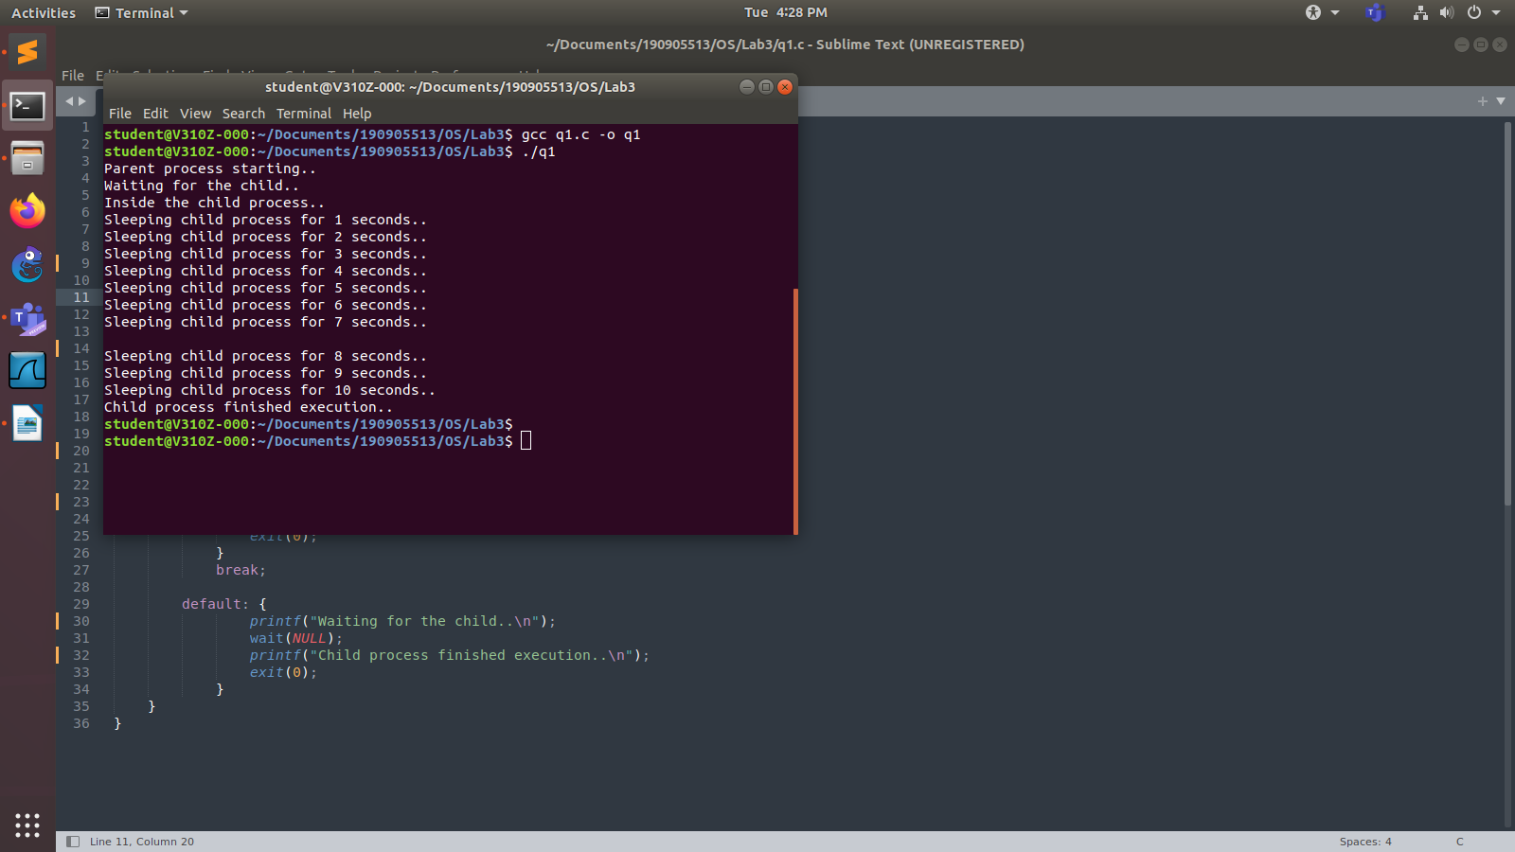

2. Write a C program to load the binary executable of the previous program in a child process using the exec system call.

Program:

#include<stdio.h>
#include<stdlib.h>
#include<unistd.h>
#include<dirent.h>
#include<sys/types.h>
#include<sys/wait.h>

int main(int argc, char const *argv[])
{
pid_t pid;
pid = fork();

if(pid < 0)
{
fprintf(stderr,"Error in creating child process\n");
exit(-1);
}

else if(pid == 0)
{
execlp("./q1.o","q1",NULL);
}

else
{
wait(NULL);
printf("Child process complete\n");
exit(0);
}

return 0;}
Output:
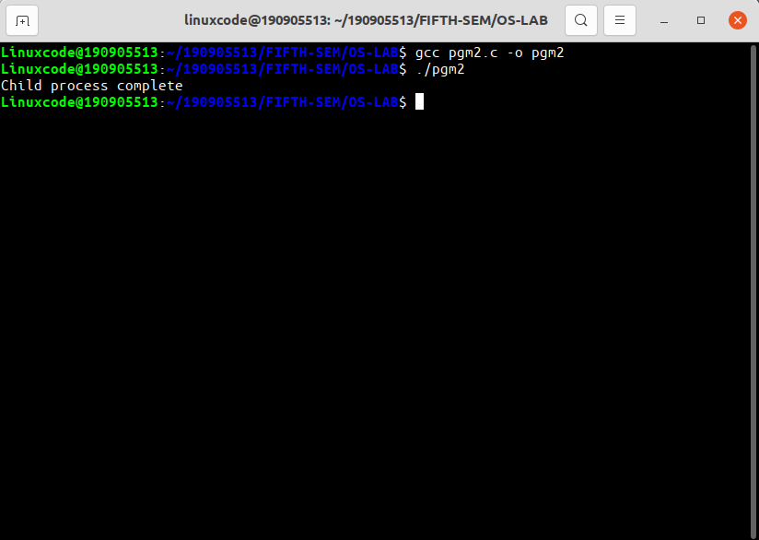

3. Write a program to create a child process. Display the process IDs of the process, parent and child (if any) in both the parent and child processes.

Program:

#include <stdio.h>
#include <stdlib.h>
#include <sys/types.h>
#include <sys/wait.h>
#include <unistd.h>

int main() {
printf("Parent process starting..\n");
int r_val = fork();

switch(r_val) {
case -1: {
perror("Fork..\n");
exit(EXIT_FAILURE);
}
break;

case 0: {
printf("Inside the child process..\n");
pid_t curr_pid = getpid();
printf("PID of child process is: %d\n", curr_pid);
exit(0);
}
break;

default: {
pid_t curr_pid = getpid();
printf("PID of parent process: %d\n", curr_pid);
printf("Waiting for child..\n");
wait(NULL);
printf("Child process finished execution..\n");
exit(0);
}
}
}

Output:
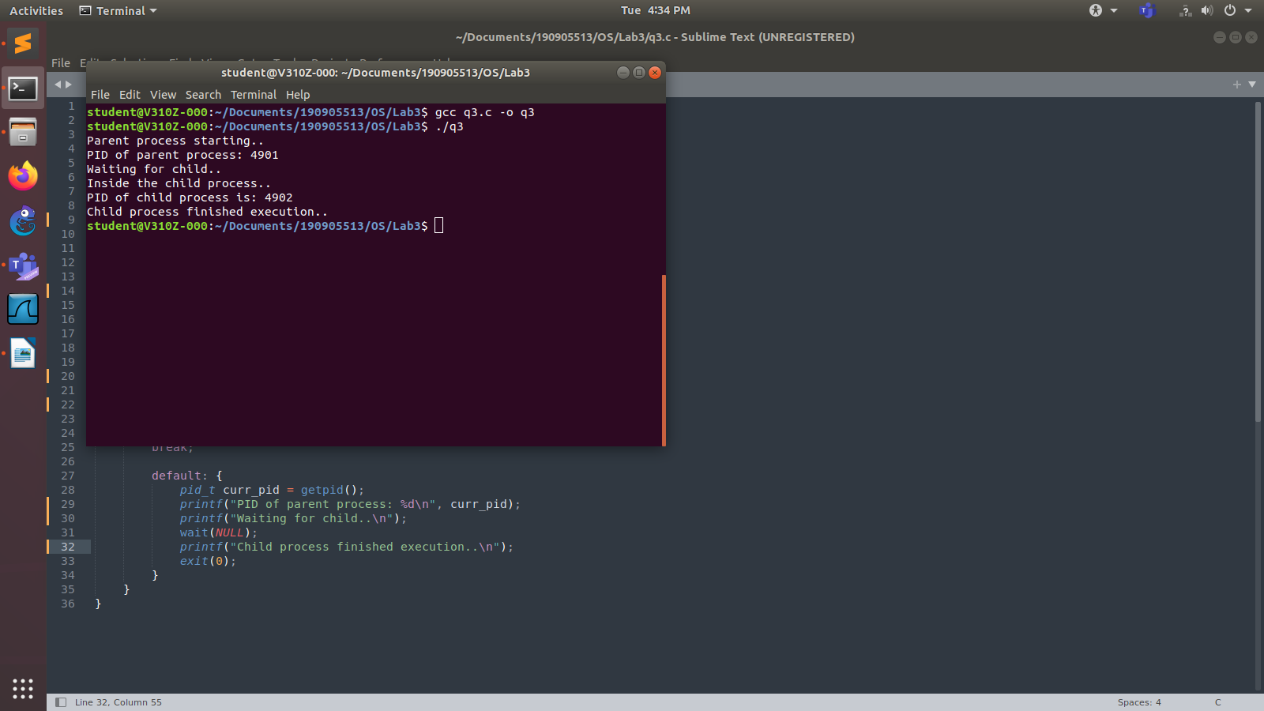

4. Create a zombie (defunct) child process (a child with exit() call, but no corresponding wait() in the sleeping parent) and allow the init process to adopt it (after parent terminates). Run the process as a backgraound process and the “ps” command.

Program:

#include <stdio.h>
#include <stdlib.h>
#include <sys/types.h>
#include <sys/wait.h>
#include <unistd.h>

int main() {
printf("Parent process starting..\n");
int r_val = fork();

switch(r_val) {
case -1: {
perror("Fork..\n");
exit(EXIT_FAILURE);
}
break;

case 0: {
printf("Inside the child process..\n");
pid_t curr_ppid = getppid();
printf("Current parent is: %d\n", curr_ppid);
for(int i = 0; i < 10; i++) {
sleep(1);
printf("Sleeping child for %d seconds..\n", i + 1);
}
curr_ppid = getppid();
printf("Current parent is: %d\n", curr_ppid);
exit(0);
}
break;

default: {
printf("Executing ps..\n");
execl("/bin/ps", "ps", NULL);
exit(0);
}
}
}

Output:
